  - Quality Policy

RiverRidge is committed to developing and maintaining a Quality Management System in accordance with the requirements of ISO9001.

The company is focused in providing services that not only meet but exceed customer’s expectations. Senior Management within the company is fully committed to the implementation of our Quality Management System. All employees are committed to the provision of a quality service.

RiverRidge employs the best people in the industry, training them to use the latest technology and software available. We can deliver an integrated waste management package that not only safe guards the environment but also finds individual solutions for our customers that are both technically effective and cost effective.

The company will improve risk management, to better control business operations and identify process improvement and controls to provide a more environmentally friendly, safe working environment as well as providing quality output of services.

The main objectives of the quality system are to:

- Ensure that our company is customer focused and responds to the needs and expectations of our customers.
- Ensure that our range of services are continually reviewed, improved and diversified.
- Ensure that we maintain a well-trained and customer focused workforce.
- Develop and maintain close liaison and good working relationships with customers and suppliers.
- Promote an environment of continual improvement in all aspects of the company’s operations.

These objectives and our Quality Management System will be subject to continual review.

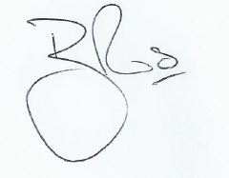

Brett Ross
Managing Director

